**Name:** Aditya Somani **Roll No:** BE1851061 **PRN:** 71901204L

**Assignment No 1**

**Aim:** Study of platform for Implementation of Assignments. Download the open source software of your interest. Document the distinct features and functionality of the software platform. You may choose WEKA and R and Python

1. **WEKA Platform Setup**

**Web Site - https://**[**www.cs.waikato.ac.nz/ml/weka/**](http://www.cs.waikato.ac.nz/ml/weka/)

Weka is a set of machine learning algorithms that can be applied to a data set directly, or called from your own Java code. Weka contains tools for data pre-processing, classification, regression, clustering, association rules, and visualisation.

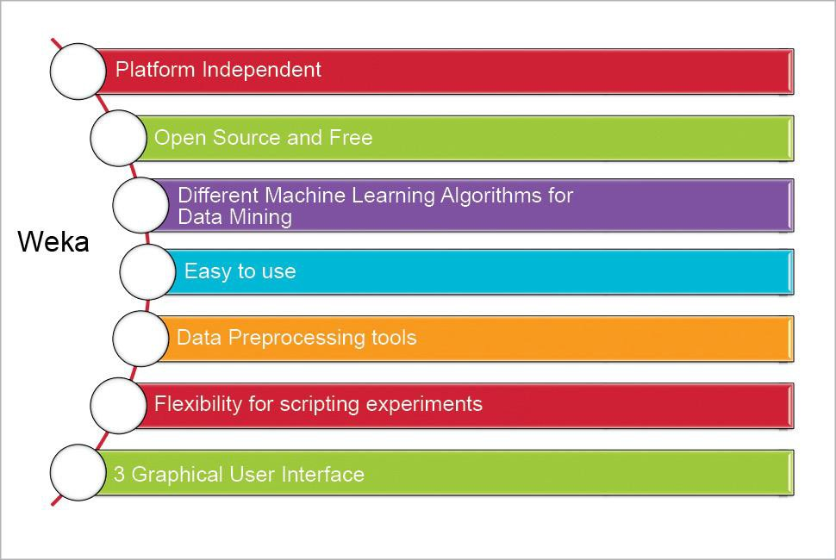

1. Make sure that you have installed JVM environment before installing following weka.

Click **here** to download a self-extracting executable for 64-bit Windows that includes Oracle's 64-bit Java VM 1.8

(weka-3-8-2jre-x64.exe; 265.4 MB)

1. If JVM is not installed then install following version of weka

Click **here** to download a self-extracting executable for 64-bit Windows without a Java VM (weka-3-8-2-x64.exe; 50.8 MB)

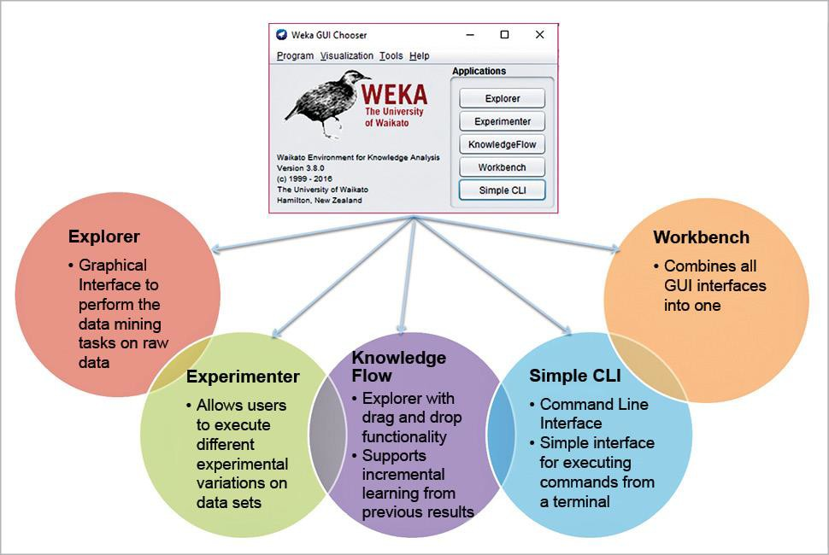

1. **Weka’s GUI allows you to:**
   * Preprocess data
   * Choose learning algorithms
   * Evaluate the results
   * Build simple visualizations
   * Form an interpretation of the results
   * Export some output

So, if you want to start machine learning algorithms without much of a coding ackground WEKA is the tool for you. Finally, after you run the weka, will are set to experiments in machine learning as follows..

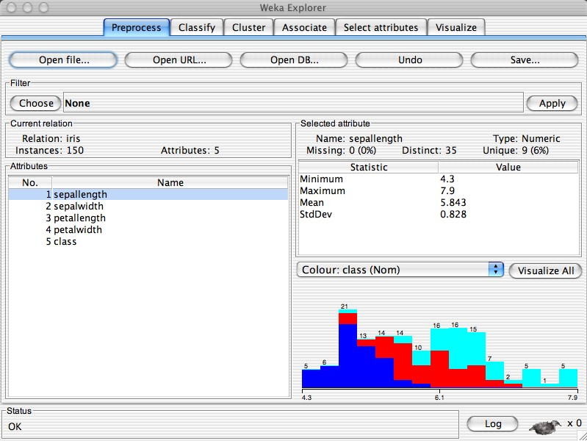

# R & Rstudio for Machine Learning

1. **Download R from** [**http://cran.us.r-project.org/.**](http://cran.us.r-project.org/)
2. Click on **Download R for Windows**. Click on **base.** Click on **Download R 3.3.2 for Windows** (or a newer version that appears).
3. Install R. Leave all default settings in the installation options.
4. Download RStudio Desktop for windows from <http://rstudio.org/download/desktop>(it should be called something like RStudio 1.0.136 — Windows Vista/7/8/10).

Choose default installation options

1. **Install the packages (Optional)**

If your need to use R requires a particular package/library to be installed in R-studio. You can follow the instructions below to do so

* 1. Run R studio
  2. Click on the Packages tab in the bottom-right section and then click on install. The following dialog box will appear
  3. In the Install Packages dialog, write the package name you want to install under the Packages field and then click install. This will install the package you searched for or give you a list of matching package based on your package text.

RStudio is a separate piece of software that works with R to make R much more user friendly and also adds some helpful features.

What can RStudio do for you?

First, RStudio gives R a point and click interface for a few of its features.

Second, RStudio adds a number of features that make your R programming easier and more efficient.

**Here are the benefits, right from RStudio’s website:**

* Syntax highlighting, code completion, and smart indentation
* Execute R code directly from the source editor
* Easily manage multiple working directories using projects
* Quickly navigate code using type ahead search and go to definition

***An IDE built for R***

* Workspace browser and data viewer
* Plot history, zooming, and flexible image and PDF export
* Integrated R help and documentation
* Searchable command history

**IDE looks like as follows after you install and start RStudio**

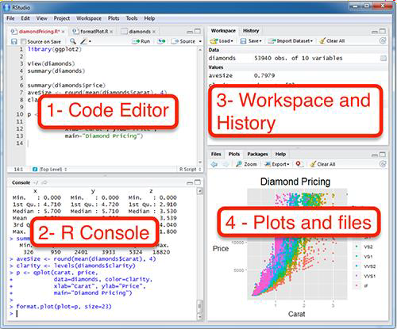

1. **Anakonda, Python, Jupyter notebook for Machine Learning**

There are a lot of environments that are available for free in the internet , where you could straight away go and start Programming, but [Anaconda](https://www.google.co.in/url?sa=t&rct=j&q&esrc=s&source=web&cd=6&cad=rja&uact=8&ved=0ahUKEwjlpcC9uIHYAhWFOI8KHUZ5AKIQFghIMAU&url=https%3A%2F%2Fen.wikipedia.org%2Fwiki%2FAnaconda_%28Python_distribution%29&usg=AOvVaw3iBGo2cHta6YIvjaEgJeOm) powered by [Continuum Analytics](https://www.google.co.in/url?sa=t&rct=j&q&esrc=s&source=web&cd=1&cad=rja&uact=8&ved=0ahUKEwjQqO_RuYHYAhVJrY8KHeZxDjMQFggoMAA&url=http%3A%2F%2Fwww.continuumanalytics.com%2F&usg=AOvVaw0wwLiTnit1q0iCMCsIBx6h) is an environment that anyone could use to program in Python and R.

If you use wish to program in Python, then [Jupyter Notebook](https://www.google.co.in/url?sa=t&rct=j&q&esrc=s&source=web&cd=1&cad=rja&uact=8&ved=0ahUKEwiSzb7quYHYAhVMKo8KHdrfCacQFggoMAA&url=http%3A%2F%2Fjupyter.org%2F&usg=AOvVaw2BGkfjMHm2Y7GNO_mDEeDH) is your place, where you have access to a lot of scientific and Numeric Libraries and if you are more of an Analytical Person than solving scientific problems then there is [R studio](https://www.google.co.in/url?sa=t&rct=j&q&esrc=s&source=web&cd=1&cad=rja&uact=8&ved=0ahUKEwihi437uYHYAhULNI8KHbGZDeEQFggoMAA&url=https%3A%2F%2Fwww.rstudio.com%2F&usg=AOvVaw1bt9MYkG-ySe7hgo9R8XTb) where a ready environment is available for persons who wish to code in R

**Installing Anaconda:**

* + click on this link to get Anacondas in the web, https://[www.anaconda.com/download/](http://www.anaconda.com/download/)
  + Select the required OS that you have in your PC, (Linux, Windows, Mac)
  + After downloading your file, install your software in the system.
  + This will be your main screen of your Anaconda Prompt. This is just like a chrome where you get stuffed with a lot of webpages, but here with a lot of different tools that Anaconda is offering to us such as Jupyter, R studio, Orange, Spyder,etc..

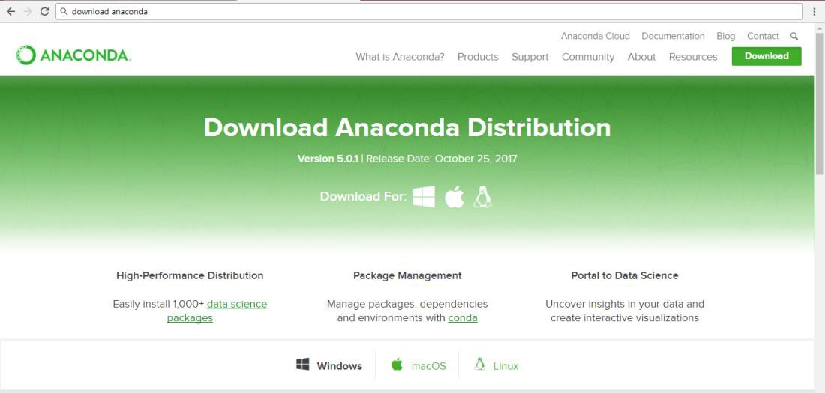

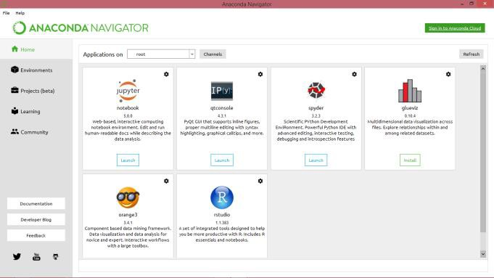

Congratulations for setting up your Environment to code your Machine Learning Algorithm.

# Python and Jupyter Notebook ( Alternate installation) 64bit or 32 bit

This section shows downloading and installing Python 3.6.2 on Windows 10. **You should download and install the latest version of Python.** The current latest is Python 3.6.4.

The Python download requires about 30 Mb of disk space; keep it on your machine, in case you need to re-install Python. When installed, Python requires about an dditional 90 Mb of disk space.

**Downloading**

## Click Python Download.

The following page will appear in your browser.

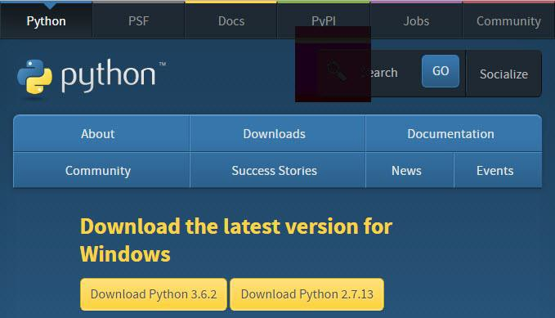

1. Click the **Download Python 3.6.2** button.

The file named **python-3.6.2.exe** should start downloading into your standard download folder. This file is about 30 Mb so it might take a while to download fully if you are on a slow internet connection (it took me about 10 seconds over a cable modem).

The file should appear as 

1. Move this file to a more permanent location, so that you can install Python (and reinstall it easily later, if necessary).
2. Feel free to explore this webpage further; if you want to just continue the installation, you can terminate the tab browsing this webpage.
3. Start the **Installing** instructions directly below.

**Installing**

1. Double-click the icon labeling the file **python-3.6.2.exe**.

An **Open File - Security Warning** pop-up window will appear.

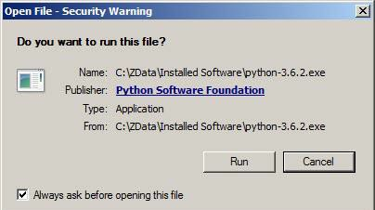

1. Click **Run**.

A **Python 3.6.2 (32-bit) Setup** pop-up window will appear.

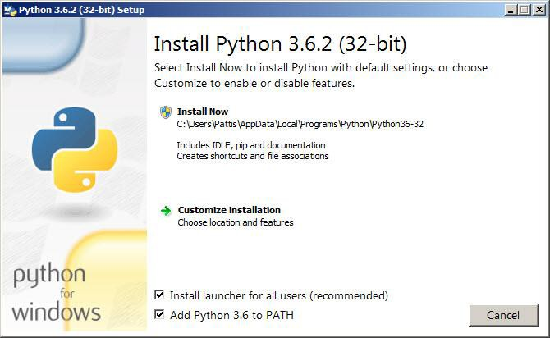

Ensure that the **Install launcher for all users (recommended)** and the **Add Python 3.6 to PATH** checkboxes at the bottom are checked.

If the Python Installer finds an earlier version of Python installed on your computer,

the **Install Now** message will instead appear as **Upgrade Now** (and the checkboxes will not appear).

1. Highlight the **Install Now** (or **Upgrade Now**) message, and then click it.

A **User Account Conrol** pop-up window will appear, posing the question **Do you want the allow the following program to make changes to this computer?**

1. Click the **Yes** button.

A new **Python 3.6.2 (32-bit) Setup** pop-up window will appear with a **Setup Progress** message and a progress bar.

During installation, it will show the various components it is installing and move the progress bar towards completion. Soon, a new **Python 3.6.2 (32-bit) Setup** pop-up window will appear with a **Setup was successfuly** message.

1. Click the **Close** button.

## Python should now be installed.

Verifying

## To try to verify installation,

1. Navigate to the directory **C:\Users\Pattis\AppData\Local\Programs\Python\Python36- 32** (or to whatever directory Python was installed: see the pop-up window for Installing step 3).
2. Double-click the icon/file **python.exe**.

The following pop-up window will appear.

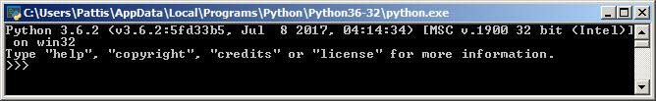

A pop-up window with the title **C:\Users\Pattis\AppData\Local\Programs\Python\Python36- 32** appears, and inside the window; on the first line is the text **Python 3.6.2 ...** (notice that it should also say 32 bit). Inside the window, at the bottom left, is the prompt **>>>**: type **exit()** to this prompt and press **enter** to terminate Python.

**Open the command prompt and use following commands ( make sure python scripts directory in path, set environment variable if python not running from command prompt.**

* 1. **C:>Pip list //should list all the libraries and tools**
  2. **C:>Pip install scikit-learn // Machine learning**
  3. **C:>Pip install scipy //library for scientific and technical computing**
  4. **C:>Pip install nltk //natural languages ML**
  5. **C:>Pip install matplotlib //for visualization**
  6. **C:>Pip install jupyter // installs jupyter notebook Now run the jupyter notebook with command C:>Jupyter notebook**

# And you should see the IDE shown in next section

***Or* Running Jupyter Notebook with anaconda**

**Note that** Jupyter Notebook runs on your browser, so each time you open your notebook you will be directed to your default browser. Use Chrome but some prefer Mozilla Firefox because of its timeliness.

**Click On** the Launch button for Jupyter Notebook available in your Anaconda GUI

After Clicking Launch, you will be directed to your default browser which displays web gui like this.

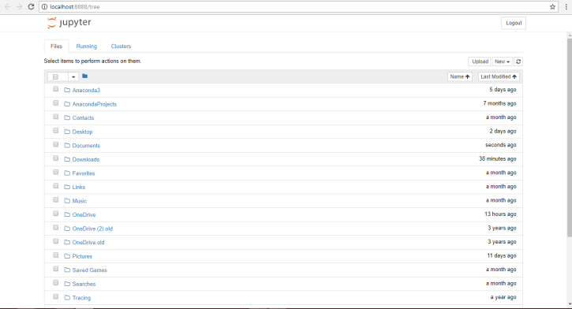

* A l**ist of folders available in your directory** will be shown here.
* To enter your code in python click **New -> python 3**
* Now you are in your first page of your python environment. Here’s where you can execute your interactive code and save it on the run time. The best thing about Jupyter Notebooks is that **it saves automatically for each time you edit your code.**

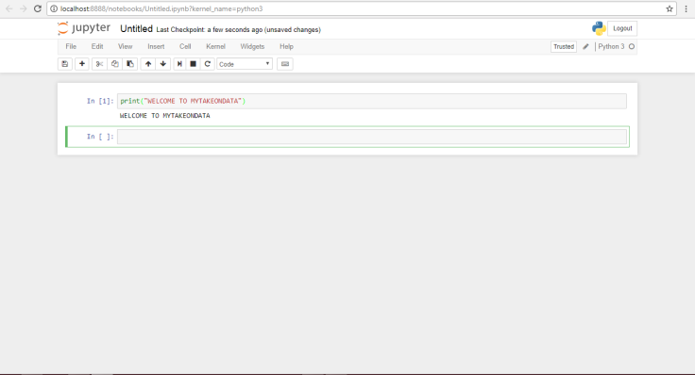

**You are ready with Weka, R and python environments in your computer and good luck for machine learning programming. Follow various ML tutorials with these tools**